**MODEL BUILDING**

**INITIALIZING THE MODEL**

|  |  |
| --- | --- |
| Team ID | PNT2022TMID14000 |
| Project Name | Project-Emerging methods for early detection of forest fires |
|  |  |

**INITIALILIZING THE MODEL:** keras has 2 ways to define a neural network:

* Sequential
* Function API

The Sequential class is used to define linear initializations of network layers which then, collectively, constitute a model. In our example below, we will use the Sequential constructor to create a model, which will then have layers added to it using the add () method.

Now, will initialize our model.

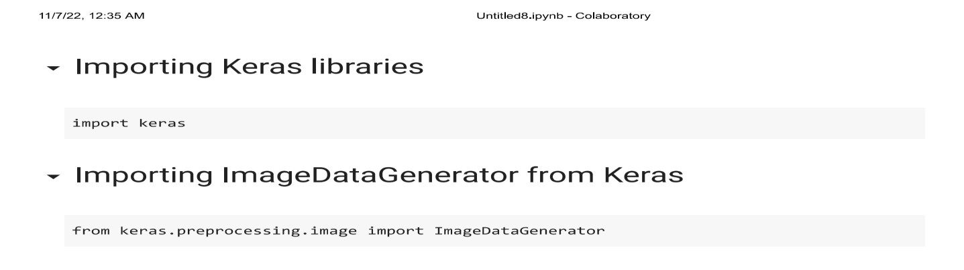

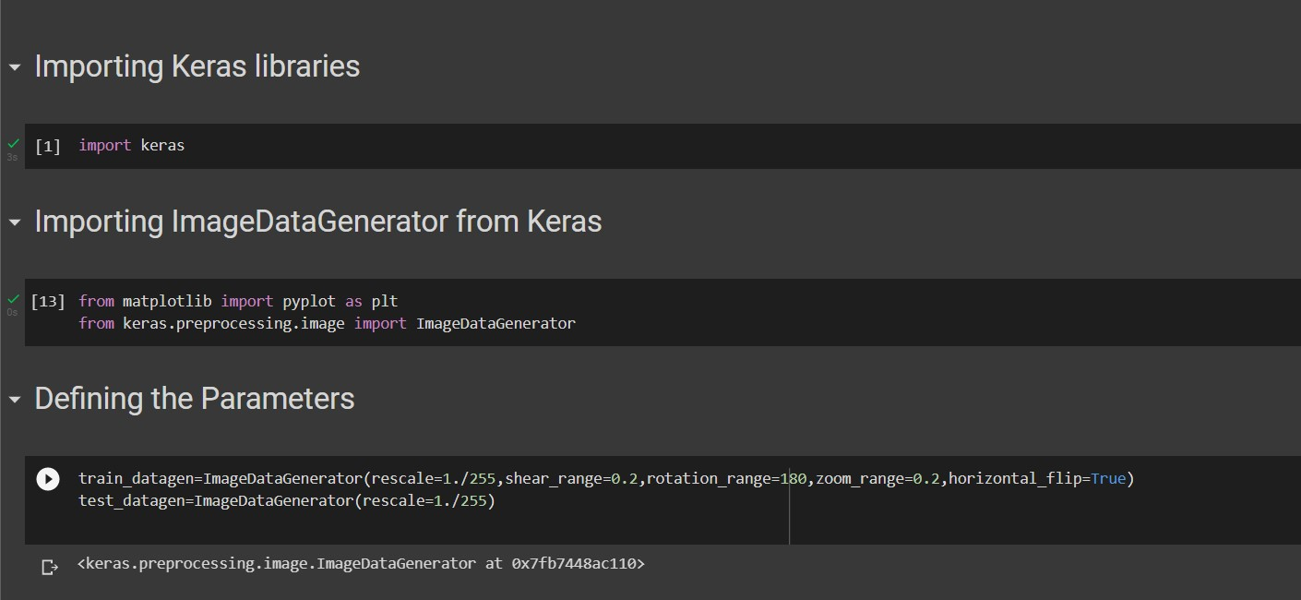

**APPLYING ImageDataGenerator to train dataset:**

ply**flow_from_directory ( )**methodfor Train folder.

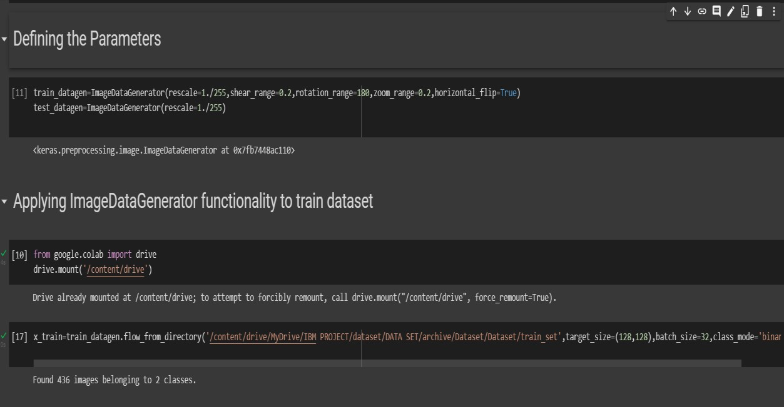

**APPLYING ImageDataGenerator to test dataset:**

Applying the **flow_from_directory ( )** methodfortest folder.

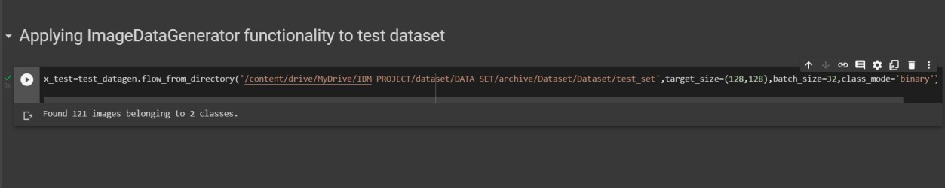

**IMPORTING MODEL BUILDING LIBRARIES:**

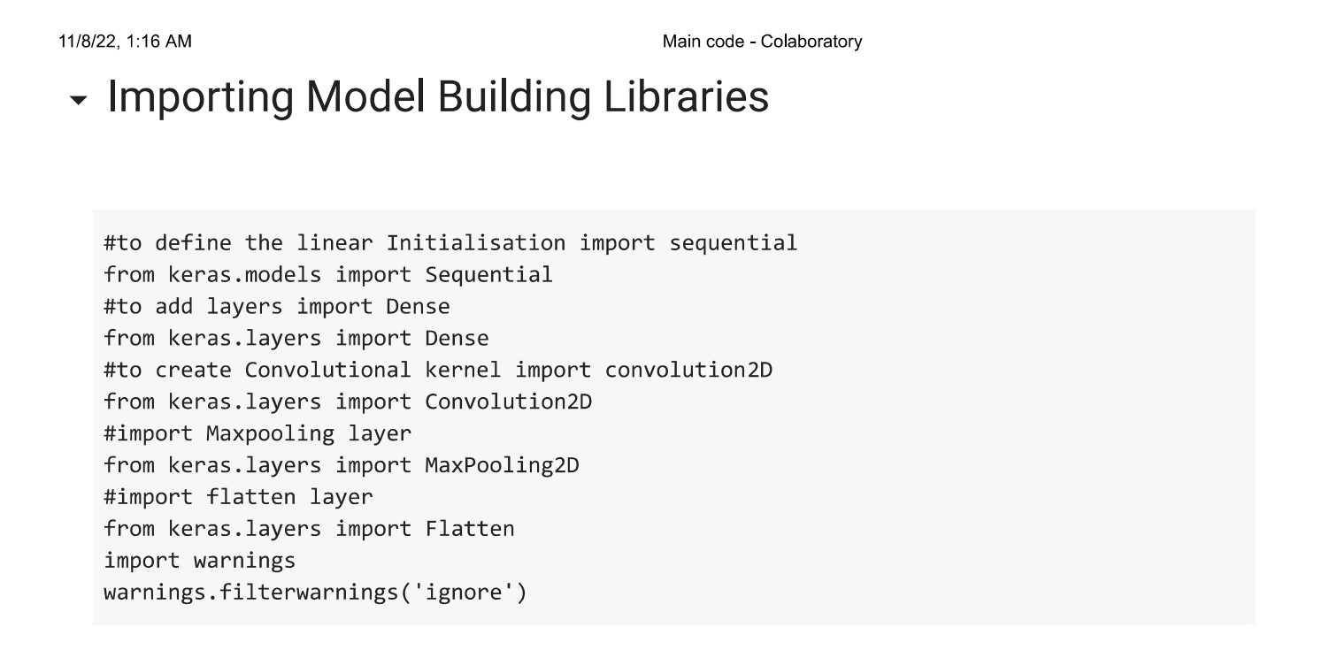

**INITIALIZING THE MODEL:**

